Zewail City of Science, Technology and Innovation University of Science and Technology
School of Computational Sciences and Artificial Intelligence
CSAI 203 - Fall 2025

Introduction to Software Engineering
All-in-one AI Project Management and DevOps Platform
Design Phase Document
Team Number: #21
Team Members:
Ahmed Mohsen Abdelsattar 202301138
Jana Ahmed Mohamed 202301800
Ali Bahaa Eldin Elrouby 202301680
Mazen Ahmed Galal 202300900
Hany Mohamed Abdulfattah 202302380

1. Introduction
1.1 Purpose of the Document
The purpose of this Design Phase Document (DPD) is to translate the comprehensive set of validated requirements outlined in the Software Requirements Specification (SRS) into a detailed, executable technical blueprint for the development of our AI Project Management system. This document acts as the foundational architecture, defines the technology stack, specifies internal and external interfaces, and details the data models necessary for implementation. It serves as the primary technical reference for the development and quality assurance teams, ensuring that the final system meets all functional and non-functional requirements (FRs and NFRs) specified in the SRS.
1.2 Scope of the Design Phase
- Architectural Design: Defining the structure, components, and communication patterns of the Service-Oriented Architecture (SOA).
- Component Specification: Making all the sequence diagrams and the system architecture diagrams to detail every functionality of the functional requirements.
- Data Design: Creation of the logical and physical data models for all domain databases.
- UI creation: Making wire frames to the whole design to imagine the project shape before coding it.
1.3 Intended Audience
- Software Architects and Leads: To validate the overall design approach and ensure compliance with industry best practices and organizational standards.
- Development Team: To serve as the definitive guide for coding, component integration, and also making testcases to test the project after finalizing it.
- Project Managers and Stakeholders: To understand the technical approach, resource dependencies, and critical design decisions underlying the implementation timeline.
1.4 Overview of the Contents
- Section 2: System Overview provides a high-level description of the system, its purpose, and outlines the primary design goals and constraints driving the architecture.
- Section 3: Architectural Design fully specifies the chosen Service-Oriented Architecture (SOA), including a visual System Architecture Diagram, a discussion of the architectural style and components, and the finalized Technology Stack and Tools.
- Section 4: Detailed Design is the core technical section, detailing the application of the Model-View-Controller (MVC) design pattern, presenting detailed UML Class and Sequence Diagrams, illustrating the proposed UI/UX via Wireframes/Mockups, and specifying the final Data Design, including the Database Schema/File Structure and Data Dictionary.
- Section 5: Conclusion provides a summary of the key design decisions and final output generated during this phase.
2. System Overview
2.1 Brief Description of the System

2.2 Key Design Goals and Constraints

3. Architectural Design
3.1 System Architecture Diagram

3.2 Discussion of Architectural Style and Components

3.3 Technology Stack and Tools
Frontend: HTML, CSS and JS
Backend: Python (Flask)
Database: PostgreSQL/MySQL/MongoDB
Cloud hosting: AWS/Azure/Docker

4. Detailed Design
4.1 Model–View–Controller (MVC) Design Pattern
4.1.1 Description of MVC
The Model-View-Controller (MVC) is an architectural pattern selected to separate the application logic from the user interface. This structure is critical for managing the complexity of AIPMS, which incorporates traditional project management with advanced Artificial Intelligence (AI) and multiple external integrations.
- Model: The business logic, data, state management, and the core data objects (e.g., Task, Project) reside here. It is independent of the user interface.
- View: Responsible for displaying the Model's data and capturing all user input (e.g., clicks, form submissions) .
- Controller: Acts as an intermediary, receiving user requests from the View, executing the appropriate logic in the Model, and selecting the next View to be rendered .
Rationale for Choosing MVC: MVC was chosen to meet the non-functional requirements of scalability (for at least 10,000 users ) and maintainability. The separation of concerns ensures that the Flask (Python)-based application logic can be modified independently of the HTML5/CSS3/JavaScript frontend. This is essential for a system with mandatory AI components and frequent third-party API updates.
4.1.2 Mapping of Project Components to MVC
The core components and technologies of AIPMS map directly to the MVC layers: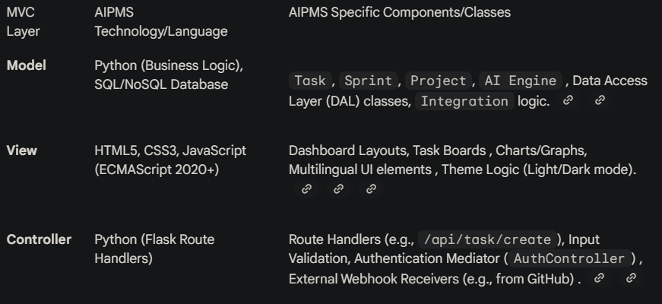
4.1.3 Responsibilities of Model, View, and Controller
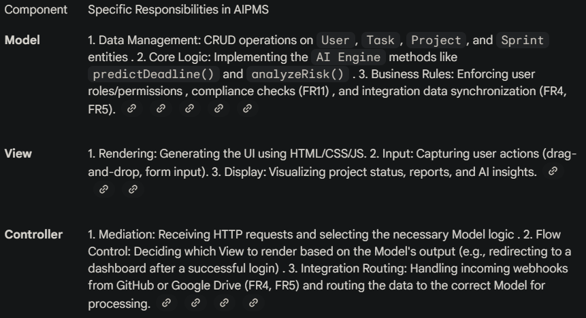
4.1.4 Interaction Between Components
The AIPMS interaction flow is a request/response cycle, often initiated by a user, that travels through the MVC components.
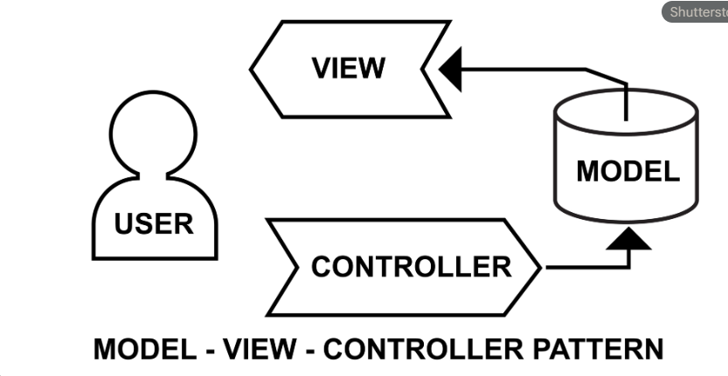
Example Flow: Automated Sprint Adjustment (FR3)
- Internal Trigger (Model): The AI_Engine model detects a significant task delay within a Sprint.
- Model Logic (Model): The AI_Engine calls a method on the Sprint model, which executes the Adjust Sprint Automatically logic, updating task deadlines and potentially reassigning resources .
- Notification (Model/Controller): The updated Sprint model notifies the Notification model. The IntegrationController then sends an alert to the Project Manager via Slack or Email (FR6).
- View Update (Controller to View): The TaskController detects the change in the Model state (via an observer pattern or direct Model call) and sends the newly calculated sprint data to the ProjectBoardView for rendering.
- Display (View): The user interface displays the adjusted sprint timeline and task workloads.

4.2 UML Diagrams
The Detailed Class Diagram maps the core entities from the Domain Model (the Model layer) to their respective Controller and View classes to formalize the MVC architecture. This structure ensures a clean separation of responsibilities, making the system easier to develop and test.
4.2.2 Detailed Class Diagram 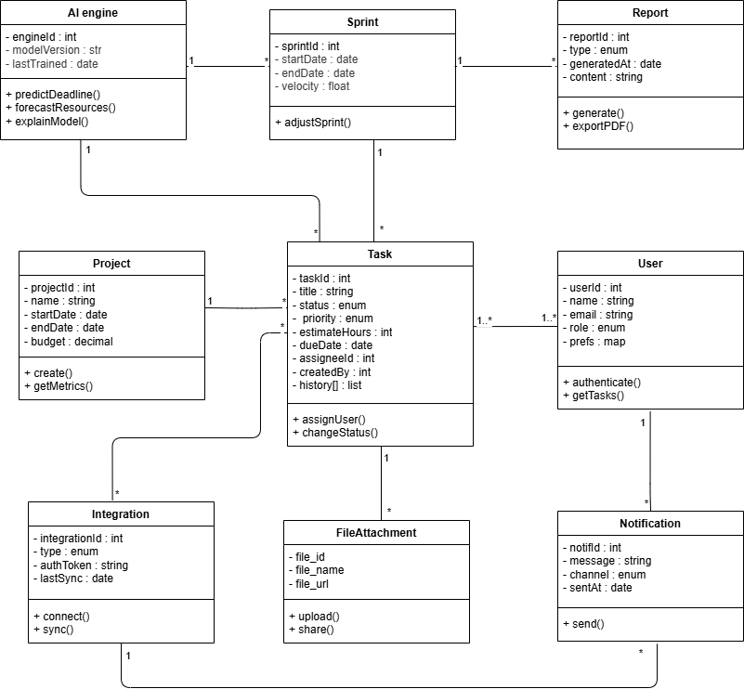
1. User
Description:
Represents any individual who interacts with the system (team member, project manager, or admin). Users are responsible for creating, assigning, and tracking tasks. Each user receives notifications and may integrate their workspace with external tools.
Attributes:
- userID : int — Unique identifier for each user.
- name : string — Full name of the user.
- email : string — User’s registered email address.
- role : string — Defines the access level (Admin, Developer, Manager, Viewer).

Methods:
- createTask() — Creates a new task under a project or sprint.
- assignTask() — Assigns a task to a team member.
- viewReport() — Views project reports.
- receiveNotification() — Handles system or integration notifications.
Relationships:
- 1..* association with Task (a user can create/own many tasks).
- 1 association with Notification (user receives notifications).
- 1..* association with Project (user participates in multiple projects).
2. Task
Description:
Represents the fundamental unit of work within a project or sprint. Tasks can be created, updated, and tracked, with AI predicting deadlines and priority adjustments.
Attributes:
- taskID : int — Unique identifier of the task.
- title : string — Short description of the task.
- description : string — Detailed information about the task.
- status : string — Task state (e.g., To Do, In Progress, Done).
- deadline : date — AI-predicted or user-defined completion date.
Methods:
- updateStatus() — Updates the current task status.
- attachFile() — Links a file or document to the task.
- linkIntegration() — Syncs related GitHub commits or external data.
Relationships:
- 1..* association with User (each task is created or assigned to one or more users).
- 1 composition with Sprint (a sprint contains multiple tasks).
- 1 aggregation with FileAttachment (a task can have attached files).
- 1 association with AI Engine (AI predicts deadlines and adjusts schedules).
3. Sprint
Description:
A defined time-boxed iteration in a project. It organizes multiple tasks and reports progress. AI models analyze velocity, predict completion, and suggest adjustments.
Attributes:
- sprintID : int — Unique sprint identifier.
- startDate : date — Sprint start date.
- endDate : date — Sprint end date.
- velocity : float — Speed of task completion based on past data.
Methods:
- addTask() — Includes a task in the sprint.
- generateSprintReport() — Produces a sprint progress report.
Relationships:
- 1..* composition with Task (each sprint contains many tasks).
- 1 association with Project (belongs to one project).
- 1 association with Report (each sprint generates reports).
- 1 association with AI Engine (AI adjusts sprint scope and duration).

4. Project
Description:
Represents a complete project in the system. Each project includes multiple sprints, tasks, and associated users.
Attributes:
- projectID : int — Unique identifier for each project.
- name : string — Project name.
- description : string — Summary of the project scope and goals.
- startDate : date — Project start date.
- endDate : date — Project completion date.
Methods:
- createSprint() — Starts a new sprint for the project.
- addMember() — Adds users to the project.
- generateProjectReport() — Compiles all reports related to this project.
Relationships:
- 1..* composition with Sprint (a project has one or more sprints).
- 1..* association with User (many users work on a project).
- 1 association with Report (reports summarize project performance).
5. Report
Description:
Provides visual and textual summaries of project or sprint performance. It can include AI analytics, risk assessments, and velocity trends.
Attributes:
- reportID : int — Unique identifier of the report.
- type : string — Report type (e.g., sprint, project, AI analysis).
- date : date — Date of report generation.
- content : string — Summary and analytics details.
Methods:
- generateReport() — Creates a report automatically.
- exportReport() — Exports reports as PDF or Excel files.
Relationships:
- 1 association with Sprint (each sprint generates one or more reports).
- 1 association with Project (summary reports per project).
6. AI Engine
Description:
Acts as the system’s intelligence core, analyzing historical data, predicting deadlines, estimating workloads, and detecting potential risks.
Attributes:
- modelVersion : string — Version of the AI model.
- lastTrained : date — Date the model was last trained.

Methods:
- predictDeadline() — Predicts task completion times.
- forecastVelocity() — Forecasts sprint completion trends.
- analyzeRisk() — Detects risks based on communication and data patterns.
Relationships:
- 1..* association with Sprint and Task (analyzes both).
- 1 association with Project (provides project-level insights).
7. Integration
Description:
Handles system connections with third-party services such as GitHub, Google Drive, Slack, and Email for data syncing and communication.
Attributes:
- integrationID : int — Unique integration record.
- serviceName : string — Name of the connected service.
- apiKey : string — Authentication key for the integration.
Methods:
- syncData() — Syncs commits, messages, or files.
- fetchData() — Retrieves information from integrated platforms.
Relationships:
- 1..* association with FileAttachment (Google Drive).
- 1..* association with Task (GitHub sync).
- 1..* association with Notification (Slack/Email updates).

8. FileAttachment
Description:
Represents any file uploaded or linked to a task (documents, reports, screenshots).
Attributes:
- fileID : int — Unique identifier.
- fileName : string — File name.
- fileURL : string — Cloud or local storage link.
Methods:
- uploadFile() — Uploads a file to the system.
- shareFile() — Shares the file with other team members.
Relationships:
- 1 aggregation with Task (a task may have many attached files).
- 1 association with Integration (Google Drive or other services).
9. Notification
Description:
Handles system alerts, task reminders, and integration updates. Notifications are sent to users via connected communication channels.
Attributes:
- notificationID : int — Unique notification ID.
- channel : string — Slack, Email, or in-app.
- message : string — Notification content.
- timestamp : datetime — Time sent.

Methods:
- sendNotification() — Delivers the notification.
- markAsRead() — Marks it as viewed by the user.
Relationships:
- 1..* association with User (users receive notifications).
- 1 dependency with Integration (uses third-party channels).
4.2.3 Sequence Diagrams

4.3 UI/UX Design
4.3.1 Wireframes / Mockups

4.4 Data Design
4.4.1 Database Schema / ER Diagram

4.4.3 Data Dictionary

5. Conclusion
5.1 Summary of Design Phase

